Helen G. (Sweeney) Schnepp
May 4, 1906 – February 11, 1991

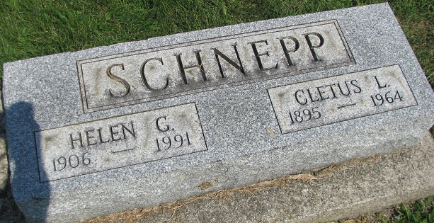
Photo by PLS

Helen G. Schnepp, 84, of Cottonwood, a nurse's aide, died Feb. 11, 1991. She was born in Cincinnati.
Survivors include her sons, Robert and Lee; one brother, six grandchildren; and seven great-grandchildren.
Rosary: 7 p.m. Thursday, Immaculate Conception Catholic Church, Cottonwood. Mass: 10 a.m. Friday at the church.
Contributions: Immaculate Conception Catholic Church Building Fund, P.O. Box 995, Cottonwood, 86326.

Westcott Funeral Homes, Inc., Phoenix, Arizona
February 14, 1991
**
U.S., Social Security Applications and Claims Index, 1936-2007
Name Helen Sweeney Schnepp
[Helen Germaine Schnepp]
[Helen Schnepp]
[Helen Sweeney Sweeney]
Gender Female
Race White
Birth Date 4 May 1906
Birth Place Cincinnati, Ohio
[Cincinnate, Ohio]
Death Date 11 Feb 1991
Father Matthew L Sweeney
Mother Anna M Tunney
SSN xxx
Notes May 1938: Name listed as HELEN SWEENEY SCHNEPP; 09 Apr 1984: Name listed as HELEN GERMAINE SCHNEPP; 14 Feb 1991: Name listed as HELEN G SCHNEPP

