Harold Edwin Schnepp
January 3, 1903 – January 13, 1957

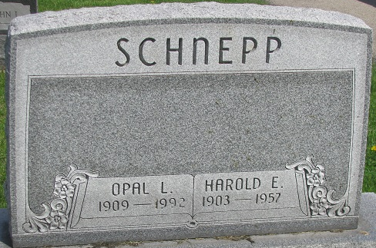
Photo by PLS

Harold E. Schnepp Dies Early Sunday
Native Of County Is Taken By Death
Harold E. Schnepp, 54, native of Adams County, who resided one and one-half miles south, and three and one-half miles east of Ossian, died at 2:45 o’clock Sunday morning at the Lutheran Hospital in Fort Wayne, following a heart attack suffered at 8 p. m. Saturday.
He was born in Adams County Jan. 3, 1903, a son of Solomon and Letitia Walters-Schnepp, and was married to Opal Wright Nov. 14, 1931. He lived in Fort Wayne from 1920 until 1936, when he moved to Wells County. He had been a machine operator of the Fort Wayne General Electric Co. for 30 years. Mr. Schnepp was a member of the Zion Lutheran Church at Friedheim, of which he was an elder, and a member of the G. E. Quarter Century Club.
Surviving in addition to his wife are a daughter, Mrs. Lee Bryant of Fort Wayne, and five brothers, Oliver, Floyd and Freeman Schnepp, all of Decatur, and Adrian and Kenneth Schnepp, of Fort Wayne. One daughter preceded him in death.
Funeral services will be conducted at 2 p. m. Wednesday at the Zwick Funeral Home, the Rev. A. A. Fenner officiating. Burial will be in the Decatur Cemetery. Friends may call at the funeral home after 7 o’clock this evening until time of the services.
Decatur Daily Democrat, Adams County, Indiana
Monday, January 14, 1957

**
Indiana, U.S., Death Certificates, 1899-2017
Name Harold Edwin Schnepp
Gender Male
Race White
Age 54
Marital Status Married
Birth Date 3 Jan 1903
Birth Place Indiana
Death Date 13 Jan 1957
Death Place Fort Wayne, Allen, Indiana, USA
Death Registration Date 1957
Father Solomon Schnepp
Mother Letitia Walters
Informant Opal Schnepp; widow; Ossian, Indiana
Burial: January 16, 1957; Decatur Cemetery; Decatur, Indiana

