Greg Dean Schnepp
April 25, 1961 – June 27, 1987

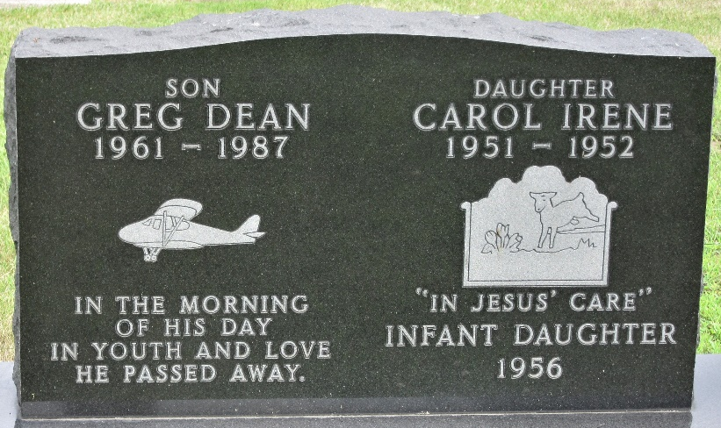
Photo by PLS

Greg D. Schnepp, 8711 Cinnamon Creek, San Antonio, TX, Age 26, died Saturday, June 27, 1987. Born in Fort Wayne, IN to Kenneth M. Schnepp and Jean (Carter) Schnepp. He was preceded in death by his father in 1985.
Surviving is his mother, Jean of Roanoke, IN; 2 brothers, Kenneth M. Schnepp, Jr. of Lansing and David M. Schnepp of Roanoke, IN; 1 sister, Tonya Schnepp of Roanoke, IN; his grandmother, Evelyn Carter of Huntington, IN.
He was a resident of Lansing from 1965 to 1985, a 1979 graduate of Harry Hill High School, and a 1985 graduate of Tri-State University, Angola, IN. He was an Aeronautical Engineer at Kelly Air Force Base, San Antonio, TX.
Calling hours are Thursday 2-4 and 7-9 p.m. at Schafer Memorial Chapel in Roanoke, IN. Funeral services will be held Friday, 10 a.m. at the Chapel.

Lansing State Journal, Lansing, Michigan
Tuesday, June 30, 1987
**
Texas, U.S., Death Index, 1903-2000
Name Greg Schnepp
Death Date 27 Jun 1987
Death County Bexar
Gender Male
**
Greg Dean Schnepp from tree Knoef Family
Birth 25 Apr 1961 Fort Wayne, Allen, Indiana, USA
Residence 26 Jun 1987 San Antonio, Bexar, Texas, USA
Death 27 Jun 1987 Bexar, Texas, USA
Father Kenneth Marion Schnepp (1923-1985)
Mother Jean Katherine Carter (1926-2013)

