Freeman Schnepp
February 15, 1897 – October 29, 1965

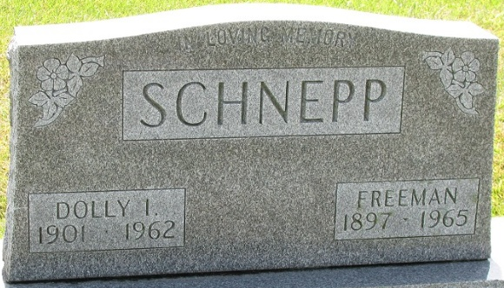
Photo by PLS

Freeman Schnepp
in the Indiana, U.S., Marriages, 1810-2001
Name Freeman Schnepp
Gender Male
Race White
Age 22
Event Type Marriage Registration (Marriage)
Birth Date 15 Feb 1897
Birth Place Adams, Indiana
Marriage Date 26 Nov 1919
Marriage Place Indiana, United States
Residence Place Adams, Indiana
Father Solomon Schnepp
Mother Letitia Walters
Spouse Dollie Burrell
Page 35

**
Ohio, County Death Records, 1840-2001

Name Freeman Schnepp
Sex Male
Age 68y
Marital Status Widowed
Occupation Salesman
Race Caucasian
Father's Name Henry Schnepp
Mother's Name Laticia Walters
Event Date 29 Sep 1965
Event Place Willshire, Willshire Township, Van Wert, Ohio, USA
Cemetery Decatur
Address 615 Short St.
Residence Place Decatur, Indiana
Birth Date 15 Feb 1897
Birthplace Indiana
Burial Date 02 Oct 1965
Burial Place Decatur Cemetery; Decatur, Indiana
Informant: Mrs. Dean Parker; Albion, Indiana

