Francis Catherine (Zerkel) Schnepp
February 21, 1895 – September 7, 1943

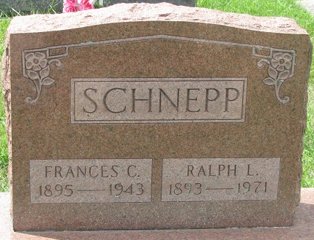
Photo by PLS

Mrs Francis Catherine Schnepp
in the Indiana, U.S., Death Certificates, 1899-2017
Name Mrs Francis Catherine Schnepp
[Mrs Francis Catherine Zerkel]
Gender Female
Race White
Age 48
Marital Status Married
Birth Date 21 Feb 1895
Birth Place Kirkland Adams Co Indiana
Death Date 7 Sep 1943
Death Place Decatur, Adams, Indiana, USA
Death Registration Date 1943
Father Jacob Zerkel
Mother Osie Bell
Spouse Ralph L Schnepp
Informant: Ralph Schnepp; Decatur, Indiana
Burial: September 9, 1943; Decatur Cemetery; Decatur, Indiana

