Floyd Schnepp
February 12, 1894 – December 3, 1964

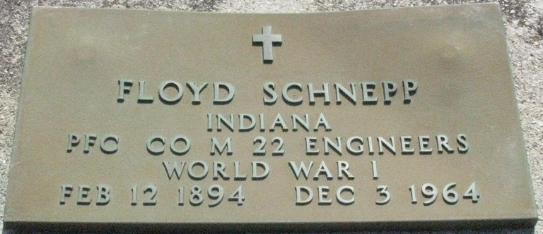
Photo by PLS

Floyd Schnepp
in the Indiana, U.S., Death Certificates, 1899-2017
Name Floyd Schnepp
Gender Male
Race Caucasian (White)
Age 70
Marital Status Never Married (Single)
Birth Date 12 Feb 1894
Birth Place Indiana
Death Date 3 Dec 1964
Death Place Decatur, Adams, Indiana, USA
Death Registration Date 1964
Father Solomon Schnepp
Mother Letitia Walters
Informant: Oliver Schnepp; brother; Decatur, Indiana
Burial: December 8, 1964; Decatur Cemetery; Decatur, Indiana

