Emma V. (McGill) Schnepp
October 7, 1871 – July 21, 1964

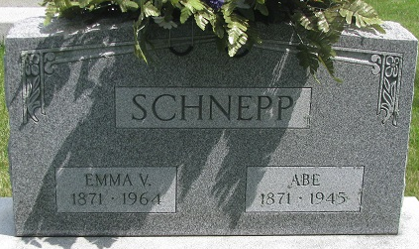
Photo by PLS

Mrs. Emma Schnepp Dies This Morning
Mrs. Emma V. Schnepp, 92, of Monroe route 1, lifelong resident of Adams County, died at 4:30 a.m. today at the Adams County Memorial Hospital. She had been ill for six months and bedfast for the past three months.
Born in Adams County Oct. 7, 1871, she was a daughter of John and Nancy Owens-McGill and was married to Abe Schnepp Sept. 25, 1892. Her husband preceded her in death Dec. 30, 1945.
Mrs. Schnepp was a member of the St. Paul Missionary Church.
Surviving are three sons, Ralph L. and John L. Schnepp, both of Decatur, and Dwight Schnepp, of Monroe route 1; two daughters, Mrs. Oren (Blanche) Shilts of Fort Wayne, and Mrs. Russell (Naomi) Kryder of Fort Wayne route 2; 11 grandchildren; 17 great-grandchildren, and three great-great-grandchildren. Four sisters and two brothers are deceased.
Funeral services will be conducted at 2 p.m. Thursday at the St. Paul Missionary church, with burial in the Decatur cemetery. The body was removed to the Zwick funeral home, where friends may call after 7 p.m. today until 11 a.m. Thursday. The body will lie in state at the church from 12 noon Thursday until of the services.

Berne Library Heritage Room, Adams County, Indiana
1962-1964 Adams County Obits
Handwritten date: Tuesday, July 21, 1964

**
Indiana, U.S., Death Certificates, 1899-2017
Name Emma V Schnepp
[Emma V McGill]
Gender Female
Race Caucasian (White)
Age 92
Marital Status Widowed
Birth Date 7 Oct 1871
Birth Place Indiana
Death Date 21 Jul 1964
Death Place Decatur, Adams, Indiana, USA
Death Registration Date 1964
Father John McGill
Mother Nancy Owens
Informant: Dwight Schnepp; son; Monroe, Indiana
Burial: July 23, 1964; Decatur Cemetery; Decatur, Indiana

