Dwight Schnepp
March 8, 1911 – June 18, 1998

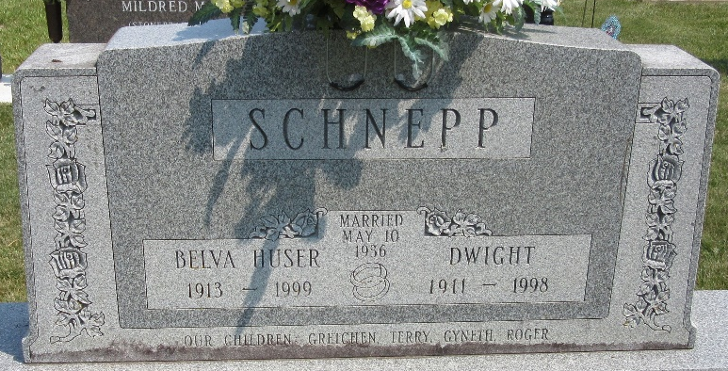
Photo by PLS

Berne – Dwight Schnepp, 87, died Thursday at Swiss Village. Born in Decatur, he was a retired farmer, and worked at Central Soya Co. for 31 years.
Surviving is his wife, Belva T.; two sons, Terry of Decatur and Roger of Portland; two daughters, Gretchen Lehman and Gyneth Augsburger, both of Berne; seven grandchildren; and six great-grandchildren.
Services at 10 a.m. Saturday at Decatur Church of God, Decatur, with calling an hour before services at the church. Calling also from 2 to 8 p.m. today at Haggard & Sefton Funeral Home, Decatur.
Burial in Decatur Cemetery, Decatur.
Memorials to the church or to Adams County Home Health Care.

Journal Gazette, Allen County, Indiana
Friday, June 19, 1998

**
Indiana, U.S., Death Certificates, 1899-2017
Name Dwight Schnepp
Gender Male
Race White
Age 87
Marital Status Married
Birth Date 8 Mar 1911
Birth Place Decatur, Indiana
Death Date 18 Jun 1998
Death Place Berne, Adams, Indiana, USA
Death Registration Date 1998
Father Abe Schnepp
Mother Emma V. McGill
Spouse Belva T. Huser
Informant: Belva Schnepp; wife; Berne, Indiana
Burial: June 20, 1998; Decatur Cemetery; Decatur, Indiana

