Dolly I. (Burrell) Schnepp
March 19, 1901 – August 25, 1962

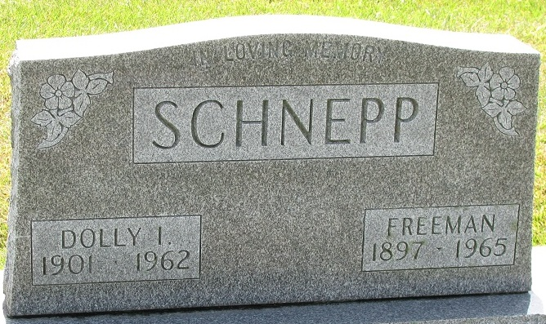
Photo by PLS

MRS. DOLLIE SCHNEPP
DECATUR - Funeral services will be at 1:30 p.m. Tuesday in the Union Chapel Evangelical United Brethren Church for Mrs. Freeman (Dollie) Schnepp, 61, of Decatur, who died Saturday morning in the Lutheran Hospital, Fort Wayne, where she had been a patient since Aug. 17.
Surviving are her husband; two daughters, her parents, Mr. and Mrs. Charles Burrell, Decatur; a brother, Clyde Burrell, Fort Wayne, and a sister. Friends may call at Zwick Funeral Home.
Adams County Historical Museum, Adams County, Indiana
January 1951 – August 1962 Scrapbook
Handwritten date: Monday, August 27, 1962

**
Indiana, U.S., Death Certificates, 1899-2011
Name: Dolly Schnepp
[Dolly Burrell]
Gender: Female
Race: White
Age: 61
Marital status: Married
Birth Date: 19 Mar 1901
Birth Place: Decatur, Ind
Death Date: 25 Aug 1962
Death Place: Fort Wayne, Allen, Indiana, USA
Father: Charles Burrell
Mother: Susan Murphy
Informant: Mrs. W. R. Klinger; sister; Leawood, Kansas
Burial: August 28, 1962; Decatur Cemetery; Decatur, Indiana

