Cletus L. Schnepp
July 17, 1895 – October 25, 1964

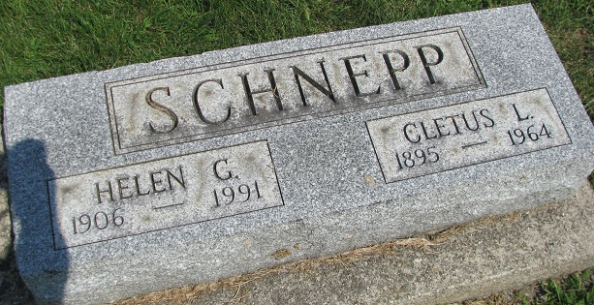
Photo by PLS

Ohio, County Death Records, 1840-2001

Name Cletus Schnepp
Sex Male
Age 69y
Marital Status Married
Occupation Blasting Contractor Retir
Race Caucasian
Father's Name Sherman Schnepp
Mother's Name Rilla Harker
Event Type Death
Event Date 25 Oct 1964
Event Place Van Wert, Pleasant Township, Van Wert, Ohio, United States
Cemetery Decatur
Address R. #2
Residence Place Ohio City, Van Wert, Ohio
Birth Date 17 Jul 1895
Birthplace Indiana
Burial Date 27 Oct 1964
Burial Place Decatur Cemetery; Decatur, Indiana
Informant: Mrs. Helen Schnepp; Ohio City, Ohio

