Charles Schnepp
April 8, 1902 – May 22, 1957

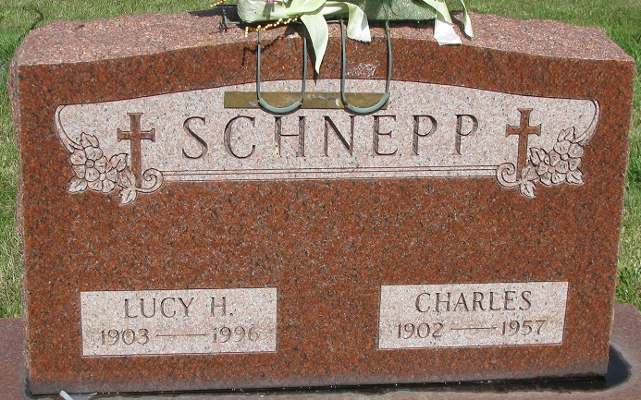
Photo by PLS

Charles Schnepp
in the Indiana, U.S., Death Certificates, 1899-2017
Name Charles Schnepp
Gender Male
Race White
Age 55
Marital Status Married
Birth Date 8 Apr 1903(sic)
Birth Place Ohio
Death Date 22 May 1957
Death Place Washington Twp, Adams, Indiana, USA
Death Registration Date 1957
Father Frank Schnepp
Mother Hannah Barrone
Informant: Mrs. Lucy Schnepp; wife; Decatur, Indiana
Burial: May 26, 1957; Decatur Cemetery; Decatur, Indiana

