Carol Irene Schnepp
January 3, 1951 – June 8, 1952

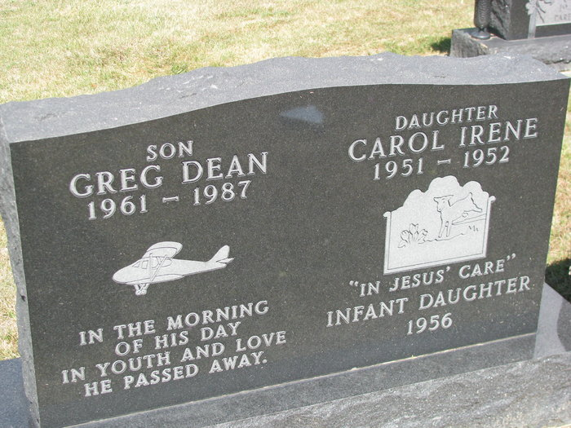
Photos by PLS

SCHNEPP GIRL DIES AT HOME ON SUNDAY

Carol Irene Schnepp, 17-month-old daughter of Mr. and Mrs. Kenneth Schnepp, died at 7 a.m. Sunday at the home, 1322 High Street. The child had been ill since birth Jan. 3, 1951.
Surviving are the parents, two brothers, Kenneth Jr., and David Michael; the grandparents, Mr. and Mrs. Virgil Carter of Fort Wayne, Oliver Schnepp of Decatur, Mrs. Lena Schnepp of Williamsburg, Va., and great-grandmothers Mrs. Lettie Schnepp of Union Township and Mrs. Jacob Duff of Chattanooga, O.

Decatur Daily Democrat; Adams County, Indiana
Monday, June 9, 1952

