Bruce A. Schnepp
July 1, 1932 – January 28, 2021

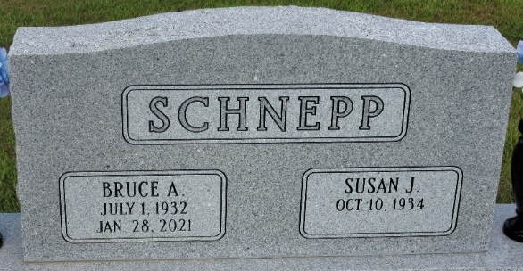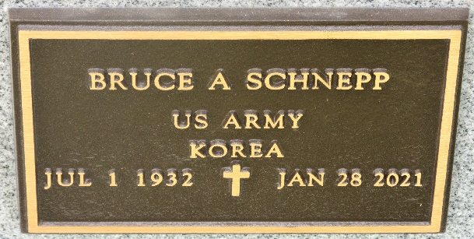
Photo by PLS

Bruce A. Schnepp, 88, of Decatur, IN, passed away on Thursday, January 28, 2021, at Adams Heritage in Monroeville. He was born in Decatur, IN, on July 1, 1932, the son of the late Charles and Lucy (Bowsher) Schnepp. On April 11, 1952, he married Susan J. Bowman.
He was a 1950 graduate of Adams Central High School. In 1953, Bruce went on to serve his country in the U.S. Army during the Korean War, where he was in the 23rd Infantry Regiment and attained the rank of Sergeant before being honorably discharged in 1955.
Bruce was a millwright for Corning Glass in Bluffton until it closed. He then relocated to and retired from General Motors in Marion. He was a member of the American Legion Post 43.
Not only was Bruce a talented millwright, he could fix anything. If you wanted to find him, he was in his shop fixing and tinkering. He built and owned and operated a go-kart race track in the ‘60s in Monroe. His love for speed made him an avid NASCAR fan.
He is survived by his wife of 68 years, Susan J. Schnepp of Decatur; 4 children, Jennifer J. (Charles) Olson of Lancaster, OH, Nancy A. (Donald “Chip”) Holt of Coldwater, MI, Michelle A. (Todd) Tesznar of Felton, DE, and Dr. Bruce C. Schnepp (Dr. Linda Liu) of Havertown, PA; 6 grandchildren, Tiffany (Zach Sandner) Peters, Crystal (Adam) Madson, Paige Holt, Tyler Olson, Morgan Tesznar, and Nicholas Schnepp; 4 great grandchildren, Lucas & Brody Madson and Paisley & Ryker Sandner. He was preceded in death by a brother and a sister.
Visitation will be from 2:00 – 7:00 p.m. on Monday, February 1, 2021, at Haggard-Sefton-Hirschy & Zelt Funeral Home. Face masks are required. A Private Funeral Service will be held for the immediate family. Military Funeral Honors will be rendered by the American Legion Post 43 Color Guard. Burial will immediately follow in the Decatur Cemetery.
Memorials may be made to Heart to Heart Hospice or the American Legion Post 43 Color Guard.

Haggard & Sefton Funeral Home, Adams County, Indiana
January 28, 2021

