Belva T. (Huser) Schnepp
February 19, 1913 – August 21, 1999

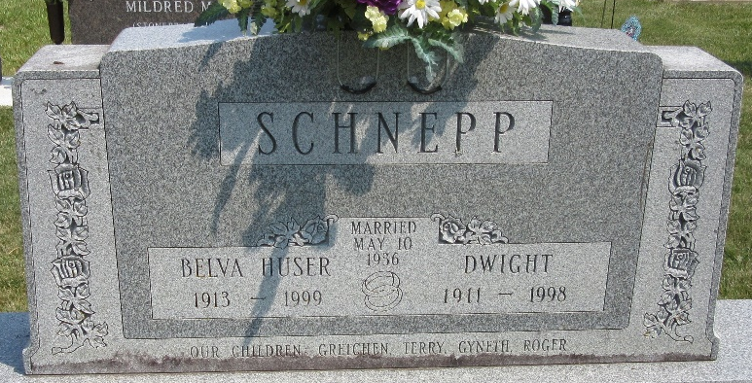
Photo by PLS

Belva T. Schnepp, 86, of Berne, a member of Decatur Church of God, died Saturday, Aug. 21, 1999, at Swiss Village. The Adams County native retired from Decatur Industries after 27 years of service. She was a member of Women of the Church of God, and Happy Homemakers Club.
Surviving are her sons, Roger D. of Black Mountain, N.C., and Terry of Decatur; daughters Gretchen Lehman and Gyneth Augsburger, both of Berne; sisters Carol Yoder and Alice Lengerich, both of Berne; seven grandchildren; and six great-grandchildren. She was preceded in death by her husband, Dwight, in 1998; and brothers Ivan and Kenneth Huser.
Services are 10 a.m. Wednesday at Decatur Church of God, Decatur. Calling is from 2 to 8 p.m. Tuesday at Haggard & Sefton Funeral Home, Decatur, and one hour before services at the church. Burial will be at Decatur Cemetery.
Memorials are to Decatur Church of God or Adams County Home Health.

News-Sentinel, Allen County, Indiana
Monday, August 23, 1999
**
Indiana, U.S., Death Certificates, 1899-2017
Name Belva T. Schnepp
[Belva T. Huser]
Gender Female
Race White
Age 86
Marital Status Widowed
Birth Date 19 Feb 1913
Birth Place Adams County, Indiana
Death Date 21 Aug 1999
Death Place Berne, Adams, Indiana, USA
Death Registration Date 1999
Father Rufus Huser
Mother Nora McClain
Informant: Gretchen Lehman; daughter; Berne, Indiana
Burial: August 25, 1999; Decatur Cemetery; Decatur, Indiana

