Adrian Schnepp
December 7, 1899 – July 29, 1961

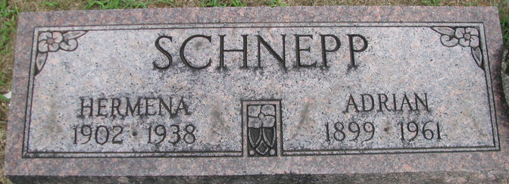
Photo by PLS

SERVICES TUESDAY FOR ADRIAN SCHNEPP
Funeral services will be held Tuesday for Adrian Schnepp, 61, of 1218 Liberty Street, Fort Wayne, who died Saturday morning in St. Luke's Presbyterian Hospital, Chicago, where he had been a patient for three weeks.
He was a native of Adams County, and was employed as a custodian for the Fort Wayne community schools.
Surviving are his wife, Esther M.; four daughters, Mrs. Betty Lorenz, Mrs. Vera Schmidt, Mrs. Dorothy Rohrbach and Mrs. Delores Ruby, all of Fort Wayne; four brothers, Freeman and Oliver Schnepp, both of Decatur, and Floyd and Kenneth Schnepp, both of Fort Wayne, and five grandchildren.
Services will be held at 1 p.m. Tuesday at the D. O. McComb & Sons Funeral Home, the Rev. L. Lyle Case officiating. Burial will be in the Decatur Cemetery. Friends may call at the funeral home until time of the services.

Decatur Daily Democrat; Adams County, Indiana
Monday, July 31, 1961
**
Name: Adrian Schnepp
Event Type: Death
Event Date: 29 Jul 1961
Event Place: Chicago, Cook, Illinois, United States
Address: 1218 Liberty Street
Gender: Male; Age: 61; Marital Status: Married
Occupation: Custodian
Birth Date: 07 Dec 1899; Birthplace: Decatur, , Indiana
Cemetery: Maplewood
Father's Name: Soloman Schnepp; Mother's Name: Letitia Walters
Entry Number: 50596; Digital Folder Number: 007589824
Image Number: 00698
Citing this Record: "Illinois, Cook County Deaths, 1871-1998," database, FamilySearch (https://familysearch.org/ark:/61903/1:1:QV9N-B55Z : 17 March 2020), Adrian Schnepp, 29 Jul 1961; citing Chicago, Cook, Illinois, United States, Cook County Courthouse, Chicago; FHL microfilm.

