Abraham Dwight Schnepp
June 7, 1871 – December 30, 1945

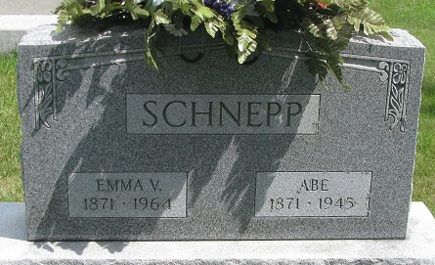
Photo by PLS

ABE SCHNEPP, 74, DIES ON SUNDAY
PROMINENT RETIRED FARMER DIES SUNDAY
RITES WEDNESDAY
Abe Schnepp, 74, a retired farmer, died Sunday afternoon at his home in Washington Township, three miles northeast of Monroe. He had been ill for one year, suffering from complications. He was bedfast for a week. Schnepp was the father-in-law of Mrs. Dwight Schnepp, formerly Belva Huser of this place. The immediate cause
of death was pneumonia which followed a siege of the flu.
Schnepp was a native of Van Wert County, Ohio, but had lived in Adams County for many years and was widely known.
Surviving are the wife, formerly Emma McGill; three sons, Dwight, at home, and Ralph and John, Decatur; two daughters, Mrs. Oren Schlitz and Mrs. Russell Kryder, Fort Wayne. Ten grandchildren and one great-grandchild survive.
The body, which was taken to the Zwick Funeral Home at Decatur, will be returned to the residence and may be viewed after 7:00 this evening. The funeral will be conducted Wednesday at 1:30 p.m. in the home and at 2:00 o’clock in St. Paul’s Church. Burial will be in the Decatur Cemetery.

Berne Witness, Adams County, Indiana
Monday, December 31, 1945

