William C. Schnepf
October 14, 1888 – February 28, 1954

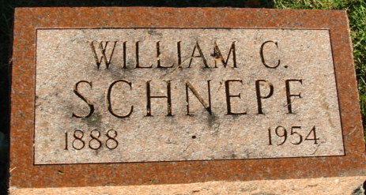
Photo by Alicia Kneuss

William C Schnepf
in the Indiana, U.S., Death Certificates, 1899-2017
Name William C Schnepf
Gender Male
Race White
Age 66
Marital Status Married
Birth Date 14 Oct 1887
Birth Place Iowa
Death Date 28 Feb 1954
Death Place Rural, Adams, Indiana, USA
Death Registration Date 1954
Father Chris Schnepf
Mother Dora Peran
Informant: Stella Schnepf; Decatur, Indiana
Burial: March 4, 1954; Decatur Cemetery; Decatur, Indiana

