Stewart P. Schnepf
July 17, 1938 – March 23, 1988

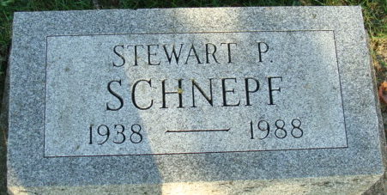
Photo by Alicia Kneuss

Stewart P Schnepf
in the Indiana, U.S., Death Certificates, 1899-2017
Name Stewart P Schnepf
Gender Male
Race White
Age 49
Marital Status Divorced
Birth Date 17 Jul 1938
Birth Place Alvord, Iowa
Death Date 23 Mar 1988
Death Place Fort Wayne, Allen, Indiana, USA
Death Registration Date 1988
Father William C Schnepf
Mother Stella Oldenburg
Informant: Jack E. Schnepf; brother; Decatur, Indiana
Burial: March 23, 1988; Decatur Cemetery; Decatur, Indiana

