Stella Dorthea (Oldenburg) Schnepf
February 14, 1892 – October 31, 1978

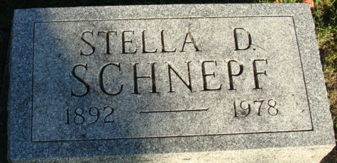
Photo by Alicia Kneuss

Stella Dorthe Schnepf
in the Indiana, U.S., Death Certificates, 1899-2017
Name Stella Dorthea Schnepf
[Stella Dorthea Oldenburg]
Gender Female
Race White
Age 86
Marital Status Widowed
Birth Date 14 Feb 1892
Birth Place Iowa
Death Date 31 Oct 1978
Death Place Fort Wayne, Allen, Indiana, USA
Death Registration Date 1978
Father William F Oldenburg
Mother Meta Kuepler
Informant: William Schnepf; Decatur, Indiana
Burial: November 2, 1978; Decatur Cemetery; Decatur, Indiana

