Dorothy Mae Schnepf
January 26, 1916 – March 11, 1978

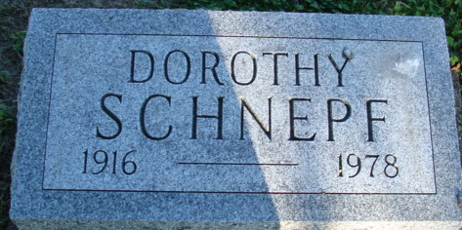
Photo by Alicia Kneuss

Dorothy Mae Schnepf
in the Indiana, U.S., Death Certificates, 1899-2017
Name Dorothy Mae Schnepf
Gender Female
Race White
Age 62
Marital Status Never Married (Single)
Birth Date 26 Jan 1916
Birth Place Iowa
Death Date 11 Mar 1978
Death Place Fort Wayne, Allen, Indiana, USA
Death Registration Date 1978
Father William C Schnepf
Mother Stella D Oldenburg
Informant: Stella D. Schnepf; Decatur, Indiana
Burial: March 13, 1978; Decatur Cemetery; Decatur, Indiana

