Warren E. Schmitt
June 16, 1926 – February 15, 1991

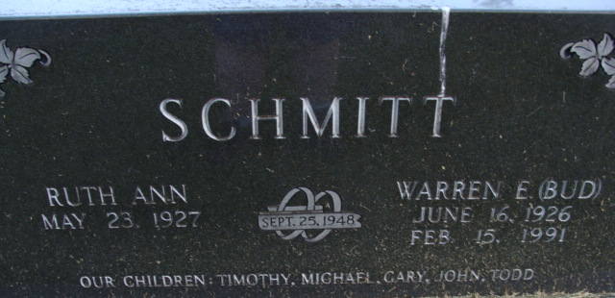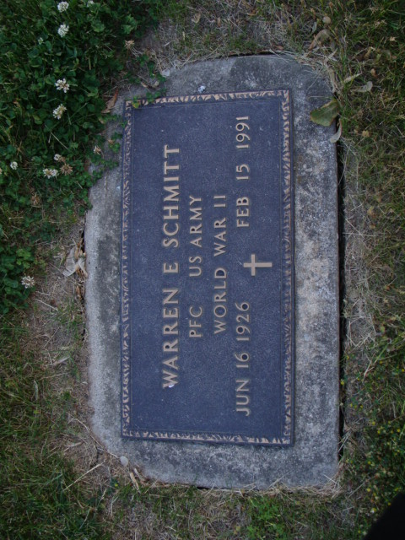
Photo by Alicia Kneuss

WARREN E. SCHMITT
Warren E. "Bud" Schmitt, 64, route 4, Decatur, died at 9:35 a.m. Friday in Floyd Memorial Hospital, New Albany, Indiana, after a brief illness. He was visiting his son in New Albany.
He was born on June 16, 1926 at Muscatine, Iowa to Elmer and Mabel Reece Schmitt. His father is deceased, but his mother lives on route 2, Decatur. He married Ruth Ann Miller on September 25, 1948; she is director of the oncology department at Adams County Memorial Hospital.
He was the former owner of Schmitt Canning Co. and a member of St. Mark's United Methodist Church, Decatur Elks Lodge 993, Adams Post 43 of the American Legion, Decatur Masonic Lodge 571, Scottish Rite, and Mizpah Shrine Temple. He was also a veteran of World War II.
Other survivors include five sons, Dr. Timothy Schmitt, New Albany; Michael Schmitt, rural Decatur; Gary Schmitt, Valparaiso; John Schmitt, South Bend; and Todd Schmitt, Indianapolis, and 12 grandchildren.
Funeral services are at 10:30 a.m. Monday in Zwick-Sefton and Jahn Funeral Home, Rev. James S. Hook officiating. Burial will be in Decatur Cemetery. Visiting hours at the funeral home are 1-9 p.m. Sunday.
Preferred memorials are to the Adams County chapter of the American Cancer society or Recordings for the Blind.
Decatur Daily Democrat; Adams County, Indiana
Saturday, February 16, 1991

