Ruth Ann (Miller) Schmitt
May 23, 1927 – May 11, 2025

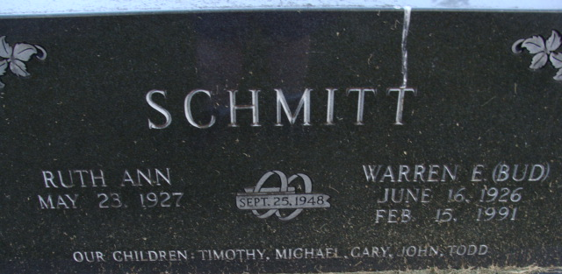
Photo by Alicia Kneuss

Ruth Ann Schmitt, 97, of Decatur, passed away Sunday, May 11, 2025, at Adams Woodcrest. She was born on May 23, 1927, in Richmond, Indiana, to the late Eugene G. and Alice T. (Hoke) Miller. On September 25, 1948, she married Warren E. “Bud” Schmitt, he preceded her in death on February 15, 1991.
Ruth moved to Decatur in 1961 and became a beloved member of Saint Marks Church in 1968, where she made many lifelong friends. She received her nursing degree from Good Samaritan Hospital in Dayton, Ohio, in 1948, and was known for her dedication and compassion.
Ruth retired from Adams County Memorial Hospital in 1992, after 22 years of service, where she was admired for her skill and kindness towards patients. She was instrumental in starting oncology services at the hospital in 1979, so patients would no longer need to travel to Fort Wayne for treatment. She was also a diabetic education nurse, at the hospital. In her retirement years, she continued to make a difference by giving flu shots through Adams County Memorial Hospital, corporate health, serving on the board of the American Cancer Society, and volunteering at the Decatur Public Library and Woodcrest. Her involvement with the American Cancer Society was particularly impactful, as she tirelessly worked to support cancer research and patient care.
Her family is deeply appreciative of the staff at Woodcrest. Their care and compassion truly touched our hearts and made a significant difference in our mother's life during the last eight years. They truly were the hands and feet of Jesus. Ruth's contributions and warmth impacted everyone around her, and her legacy will always be remembered. We invite you to share your own memories of Ruth or your experiences with her, as we come together to honor her remarkable life.
Ruth Ann is survived by her four sons, Dr. Tim E. (Susan) Schmitt of Greenville, IN, Gary R. (Kathleen) Schmitt of Cave Creek, AZ, John M. (Lisa Bryan) Schmitt of Floyds Knobs, IN, and Todd A. (Kathy) Schmitt of Decatur, IN; a daughter-in-law, Lin Schmitt; 23 grandchildren and 20 great grandchildren.
She was preceded in death by her son, Michael W. Schmitt.
A Funeral Service for Ruth Ann will be held at 11:30 a.m. on Wednesday, May 14, 2025, at St. Marks Church with visitation prior to the service, from 10:00 – 11:30 a.m. also at the church. Pastor David Reed will be officiating and burial will follow in the Decatur Cemetery.
In lieu of flowers, memorials may be made to St. Marks Church.

Haggard & Sefton Funeral Home, Adams County, Indiana
May 12, 2025

