Marguriette Irene (Sarver) Schmidt
August 26, 1907 – March 3, 2008

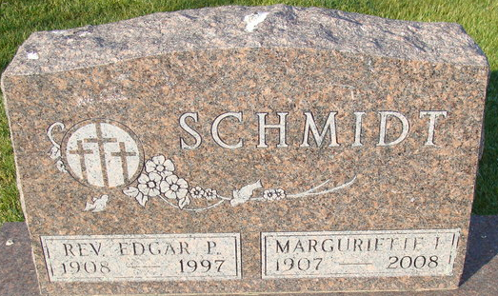
Photo by Alicia Kneuss

Marguriette Irene Schmidt 100, Indianapolis, died March 3, 2008. She was born on August 26, 1907 in Porter County, Indiana to Dallas Sarver and Catherine (Henry) Sarver, both of whom preceded her in death. She married Rev. Edgar P. Schmidt on October 24, 1937 at St. James Lutheran Church in Lafayette, Indiana. He passed away on February 6, 1997.
Edgar was the pastor for Trinity-St. Paul Church in Westville-Otis, Indiana. As Edgars ministry called, they moved to California during World War II (where they lived in Riverside, Los Angeles, and San Diego), then to Decatur, Indiana in 1948, to Lincoln, Nebraska in 1958 and to Indianapolis, Indiana in 1989.
Marguriette graduated from high school in Westville, Indiana in 1927 and graduated from Wesley Memorial Hospital, Chicago, Illinois, with a degree as a registered nurse in 1931. She had post graduate training in nursing at Cook County Hospital in Chicago, Illinois, and Geneva, New York, before working at Doctor's Hospital in New York, New York.
Marguriette was a nurse, wife, mother and friend, storyteller, gardener, cook and seamstress. Dozens, perhaps hundreds of quilts she made or helped make were sent to college students and to homeless and displaced people here and abroad. A few quilts remain with her family as a reminder of her artistry and skill. She was a member of Carmel Lutheran Church in Carmel, Indiana.
Survivors include a son, Dr. Paul (Martha) Schmidt, Indianapolis, IN; daughter, Dr. Phyllis Schmidt, Indianapolis, IN; granddaughter, Heidi Schmidt, Indianapolis, IN; grandson, Dr. C. Max (Christine) Schmidt, Indianapolis, IN; granddaughter, Loriann (Scott) Clark; and seven great grandchildren. She was preceded in death by a son, John Elliot Schmidt on May 9, 1950; two brothers, Ralph and Earl; and sister, Mildred.
A Celebration service will be held at 1 p.m. Saturday, March 8, 2008 in the Carmel Lutheran Church, 4850 E. 131st St., Carmel, IN 46033. Graveside services will be at 2 p.m. Sunday March 9, 2008 in Decatur Cemetery, Decatur, Indiana. There will be no visitation.
Memorial contributions may be made to LCMS World Relief or the Lutheran Child and Family Services of Indianapolis.

Zwick & Jahn Funeral Home, Adams County, Indiana
March 4, 2008

