John Elliot Schmidt
November 7, 1943 – May 9, 1950

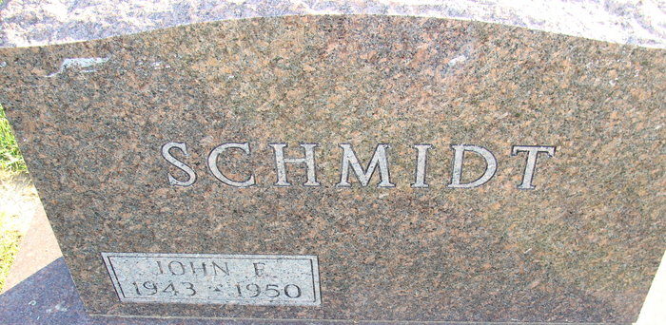
Photo by Alicia Kneuss

John Elliot Schmidt
in the Indiana, U.S., Death Certificates, 1899-2017
Name John Elliot Schmidt
Gender Male
Race White
Age 6
Marital Status Single
Birth Date 7 Nov 1943
Birth Place California
Death Date 9 May 1950
Death Place Decatur, Adams, Indiana, USA
Death Registration Date 1950
Father Edgar P Schmidt
Mother Marguriette Sarver
Informant Rev. Edgar Schmidt; Decatur, Indiana
Burial: May 12, 1950; Decatur Cemetery; Decatur, Indiana

