Rev. Edgar P. Schmidt
August 10, 1908 – February 6, 1997

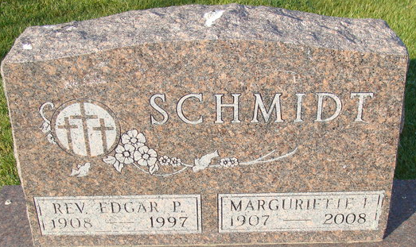
Photo by Alicia Kneuss

Edgar P. Schmidt
in the Indiana, U.S., Death Certificates, 1899-2017
Name Edgar P. Schmidt
Gender Male
Race White
Age 88
Marital Status Married
Birth Date 10 Aug 1908
Birth Place Sherwood, Ohio
Death Date 6 Feb 1997
Death Place Indianapolis, Marion, Indiana, USA
Death Registration Date 1997
Father Paul G. Schmidt
Mother Bernhardina Kramen
Spouse Margueritte Sarver
Informant: Margurietta Schmidt; wife; Indianapolis, Indiana
Burial: February 8, 1997; Decatur Cemetery; Decatur, Indiana

