Peggy (Eckles) Schmauss
December 15, 1913 – June 28, 1975

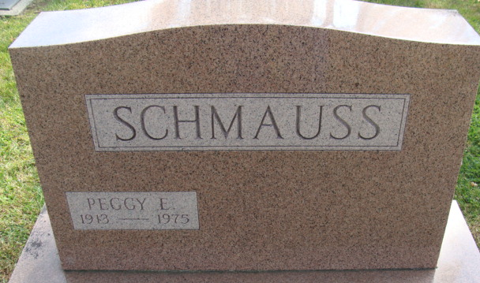
Photo by Alicia Kneuss

Peggy Schmauss
Mrs. Peggy E. (Zelma) Schmauss, 61, of Fort Wayne, stepdaughter of Earnest Figley of Decatur, died at 2:20 p.m. Saturday at the St. Joseph Hospital, Fort Wayne. Mrs. Schmauss, a waitress, was hospitalized two weeks.
Born in Van Wert county, O., on Dec. 15, 1913, she was the daughter of John and Anna Schoenstedt-Eckles, and was married to George Schmauss, who preceded her in death.
Survivors include the step-father, Earnest Figley of Decatur; one aunt, Mrs. Charles (Evelyn) Siebold of Fort Wayne, and one uncle, Clarence Schoenstedt of Van Wert.
Funeral services will be held at 10:30 a.m. Tuesday at the Winteregg-Linn & Haggard Funeral Home, with Rev. Howard Beer officiating. Burial will be in the Decatur Cemetery. Friends may call at the funeral home after 3 p.m. today.

Decatur Daily Democrat, Adams County, IN
Monday, June 30, 1975

