Nellie M. (McClain) Schlickman
August 27, 1916 – May 27, 1996

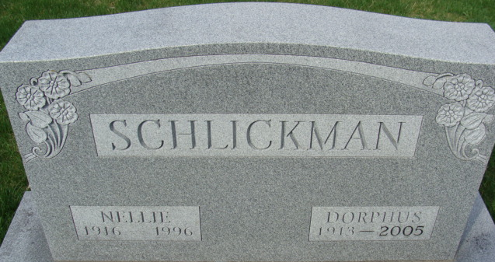
Photo by Alicia Kneuss

Nellie M. Schlickman, 79, of rural Decatur died Monday in Adams County Memorial Hospital. The Adams County native worked at G.C. Murphy Co. in Fort Wayne for 10 years.
Surviving is her husband, Dorphus H.; daughters, Rosemary Stevenson of San Mateo, Calif., and Sue McArdle of Austin, Texas; sons, Roger L. of Mazon, Ill., and Steven P. of Houston, Texas; a sister, Dorothy Neuenschwander of Fort Wayne; seven grandchildren; and a great-grandchild.
Services are 10 a.m. Thursday in St. Luke United Church of Christ, Decatur, with burial in Decatur Cemetery. Calling is 2 to 8 p.m. Wednesday in Haggard & Armes Funeral Home, Decatur, and 9 to 10 a.m. Thursday in the church.
Memorials are to the church memorial fund or Adams County Home Health Care.

**
Indiana, U.S., Death Certificates, 1899-2017
Name Nellie M Schlickman
Gender Female
Race White
Age 79
Marital Status Married
Birth Date 27 Aug 1916
Birth Place Adams County, Indiana
Death Date 27 May 1996
Death Place Decatur, Adams, Indiana, USA
Death Registration Date 1996
Father Paul Mc Clain
Mother Mary Kratzer
Spouse Dorphus H Schlickman
Informant: Dorphus Schlickman; husband; Decatur, Indiana
Burial: May 30, 1996; Decatur Cemetery; Decatur, Indiana

