Emma (Frauhiger) Schlickman
August 14, 1885 – December 15, 1969

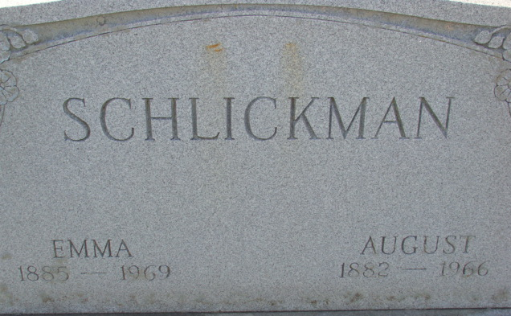
Photo of Alicia Kneuss

DECATUR, Ind. – Mrs. Emma Schlickman, 84, of Rt. 2, Decatur, died at 12:20 p.m. Monday at the Cooper Rest Home in Bluffton, Ind. She had been critically ill for one week. Born in Wells County, August 14, 1885, she was a daughter of Phillip and Bertha (Meyer) Frauhiger and was married to August Schlickman on December 14, 1905. Mr. Schlickman died March 30, 1966.
Mrs. Schlickman was a member of the St. Luke United Church of Christ.
Surviving are 3 sons, Roy R. of Gibson City, Ill., Jesse L. of Willshire, and Dorphus of Rt. 2, Decatur; 2 daughters, Mrs. Floyd (Lela) Arnold of Rt. 4, Decatur and Mrs. Ivan (Frances) Heare of Leesburg; a sister, Mrs. Forest (Nettie) Mankey of Rt. 1, Craigville, Ind.; 2 brothers, Harry Frauhiger of Decatur and Albert of Port Clinton; 21 grandchildren and 39 great-grandchildren.
Funeral services will be at 1:30 p.m. Thursday at the Zwick Funeral Home in Decatur, the Rev. John Dulin to officiate. Burial will be in Decatur Cemetery. Friends may call at the funeral home until the time of the services.

Van Wert Times Bulletin, Van Wert County, Ohio
Wednesday, December 17, 1969
**

Emma Schlickman is Taken by Death
Mrs. Emma Schlickman, 84, of Decatur Route 2, died at 12:20 p.m. Monday at the Cooper Rest Home in Bluffton. She had been critically ill for one week.
She was born in Wells County on Aug. 14, 1885, a daughter of Phillip and Bertha Meyer-Frauhiger, and was married to August Schlickman Dec. 14, 19005. Her husband preceded her in death March 20, 1966.
Mrs. Schlickman was a member of the St. Luke United Church of Christ and the Kirkland Ladies Club.
Surviving are three sons, Roy R. Schlickman of Gibson City, Ill., Jesse L. Schlickman of Willshire, O., and Dorphus Schlickman of Decatur Route 2; two daughters, Mrs. Floyd (Lela) Arnold of Decatur Route 4, and Mrs. Ivan (Frances) Heare of Leesburg; one sister, Mrs. Forest (Nettie) Mankey of Craigville Route 1; two brothers, Harry Frauhiger of Decatur, an Albert Frauhiger of Port Clinton, O.; 21 grandchildren and 39 great-grandchildren.
Funeral services will be conducted at 1:30 p.m. Thursday at the Zwick Funeral Home, with Rev. John Dulin officiating. Burial will be in the Decatur Cemetery. Friends may call at the funeral home after 7 p.m. today until time of the services.
Decatur Daily Democrat, Adams County, Indiana
Tuesday, December 16, 1969

