Dorphus H. Schlickman
February 14, 1913 – March 15, 2005

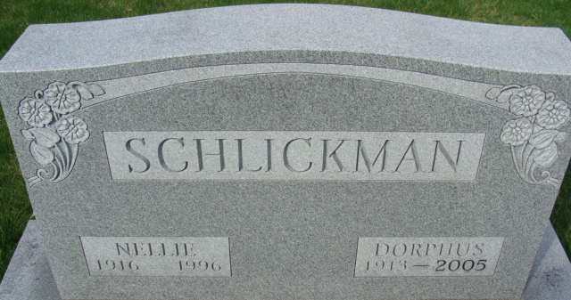
Photo by Alicia Kneuss

Dorphus H. Schlickman, 92, of Decatur, died Tuesday, March 15, 2005, at Adams Memorial Hospital, Decatur. Born Feb. 14, 1913, in Adams County, he was the son of August Schlickman and Emma (Frauhiger). He married Nellie M. (McClain) Schlickman on Dec. 2, 1938, she died May 27, 1996.
He was a lifelong member of St. Luke United Church of Christ, rural Decatur. He served as deacon of the church for many years, was one of the oldest active farmers in Adams County and was a farmer in Kirkland Township. He worked for Central Soya for several years, in Decatur and Marion, Ohio and in 1950, he worked for Citizens Telephone Co.
Surviving are two sons, Roger L. (Penny) Schlickman of Mazon, Ill. and Steve D. (Kathleen) Schlickman of Houston, Texas; two daughters, Mrs. Lash (Rosemary) Stevenson of San Mateo, Calif. and Mrs. Jim (Sue) McArdle of Austin, Texas; one sister, Frances Heare of Fort Wayne; seven grandchildren; and seven great-grandchildren. He was also preceded in death by two brothers Roy and Jessie Schlickman; and a sister, Lela Arnold.
Funeral service is 10 a.m. Saturday at St. Luke United Church of Christ, rural Decatur, with calling one hour prior. The Rev. Rick Pulling officiating. Calling also from 2 to 4 and 6 to 8 p.m. Friday at Haggard & Sefton Funeral Home, Decatur. Burial at Decatur Cemetery, Decatur.
Memorials to St. Luke United Church of Christ or the Leukemia Society of Indiana.

News-Sentinel, Allen County, Indiana
Thursday, March 17, 2005

