August Schlickman
January 9, 1882 – March 30, 1966

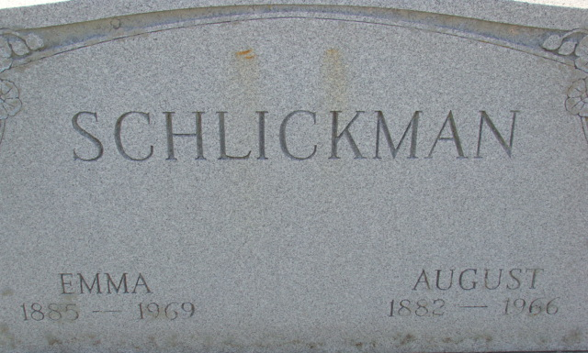
Photo by Alicia Kneuss

August Schlickman
in the Indiana, U.S., Death Certificates, 1899-2017
Name August Schlickman
Gender Male
Race Caucasian (White)
Age 84
Marital Status Married
Birth Date 9 Jan 1882
Birth Place Indiana
Death Date 30 Mar 1966
Death Place Decatur, Adams, Indiana, USA
Death Registration Date 1966
Father Ernst Schlickman
Mother Mary Lammert
Informant: Mrs. Emma Schlickman; wife; Decatur, Indiana
Burial: April 2, 1966; Decatur Cemetery; Decatur, Indiana

