Obediah J. Schleger
1860 - 1871

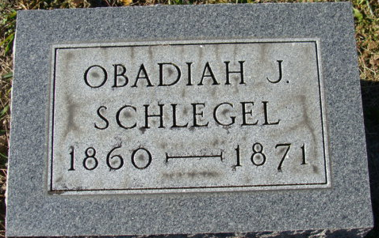
Photo by Alicia Kneuss

Obediah J Schlegel from tree Davies Family Tree
Birth 1856 Pennsylvania, USA
Residence 1870 Decatur, Adams, Indiana, USA
Death 1871
Father Daniel Schlegel (1829-1901)
Mother Angeline Kover (1827-1909)

