Daniel Schlegel
April 21, 1829 – December 28, 1901

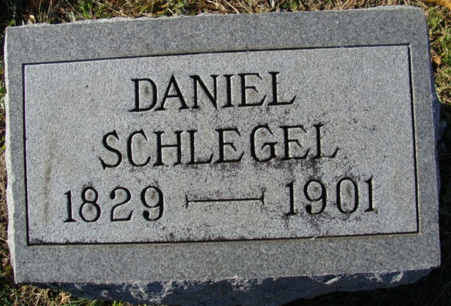
Photo of Alicia Kneuss

Daniel Schlegle, the venerable timer, died at his home on First Street on Saturday evening after a short illness with heart trouble. He was one of the best known residents here having come to Decatur over forty years ago.
He was born at Fleetwood, Pa., April 21, 1829, and was nearly seventy-three years of age. He was married in 1851 to Angeline Kover and to the union was born four children, only one of whom, Henry, survives.
Mr. Schlegle was a good, honest, Christian citizen, a member of the Baptist Church, and respected by all who knew him.
The funeral services were held Tuesday morning from the Baptist Church.

Decatur Democrat; Adams County, Indiana
A weekly newspaper
Thursday, January 2, 1902

