Angeline (Kover) Schlegel
October 28, 1827 – April 4, 1909

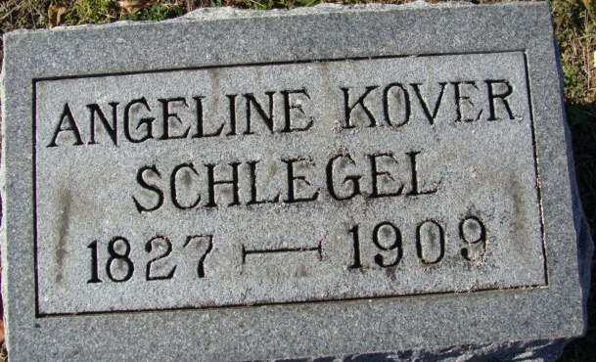
Photo by Alicia Kneuss

PIONEER WOMAN OF DECATUR DEAD
Mrs. Angeline Schlegel Passes Away at Age of Eighty-One

DECATUR, Ind., April 5 – Mrs. Angeline Schlegel nee Kover, who for more than fifty years had been a resident of this city, died last night at her home in the western part of the city, at the age of eighty-one years, five months and eight days. She was born in Pennsylvania. In 1852 she was married to Daniel Schlegel and came with him to this city in 1859. The husband died about eight years ago.
She leaves a son, Henry, of this city, a number of grandchildren, and one brother, John Kover, of Fort Wayne.
She was reared in the Reformed Church, but later transferred her membership to the Baptist Church.
The funeral will be held Tuesday afternoon at 2 o'clock from the home of Henry Krick by the Rev. I. Imler. Burial in the Decatur Cemetery.

News-Sentinel, Allen County, Indiana
April 8, 1909
**
Indiana, U.S., Death Certificates, 1899-2017 (very faded)
Name Schleyer
Gender Female
Race White
Age 81
Marital Status Widowed
Birth Date 28 Oct 1827
Birth Place
Death Date 4 Apr 1909
Death Place Decatur, Adams, Indiana, USA
Father, mother, spouse, informant Can't read
Burial April 6, 1909; Decatur Cemetery

**
Angeline Kover from tree Davies Family Tree
Birth Oct 1827 Pennsylvania, USA
Marriage 1852
Residence 1900 Adams, Indiana, USA
Death 4 Apr 1909 Decatur, Adams, Indiana, USA
Father John Kover (1799-1883)
Mother Anna Marie "Polly" Feter (1800-1870)
Spouse Daniel Schlegel (1829-1901)

