Frank M. Schirmeyer
April 1, 1854 – April 21, 1931

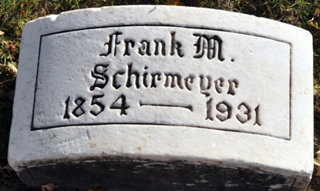
Photo by Deb Curry

Frank C Schirmeyer
in the Indiana, U.S., Death Certificates, 1899-2017

Name Frank C Schirmeyer
Gender Male
Race White
Age 77
Marital Status Married
Birth Date 1 Apr 1854
Birth Place Indiana
Death Date 21 Apr 1931
Death Place Decatur, Adams, Indiana, USA
Death Registration Date 1931
Father Charles Schirmeyer
Mother Unknown
Spouse Carrie
Informant: Mrs. F. M. Schirmeyer
Burial: April 23, 1931; Decatur Cemetery

