Carrie L. (Rout) Schirmeyer
June 19, 1863 – October 14, 1936

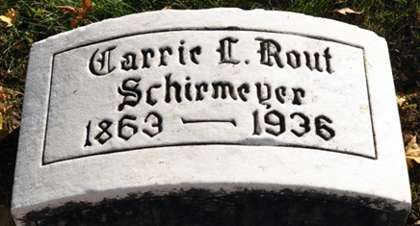
Photo by Deb Curry

Carrie L Schiermeyer
in the Indiana, U.S., Death Certificates, 1899-2017
Name Carrie L Schirmeyer
[Carrie L Rout]
Gender Female
Race White
Age 73
Marital Status Widowed
Birth Date 19 Jun 1863
Birth Place Van Wert Co Ohio
Death Date 14 Oct 1936
Death Place Decatur, Adams, Indiana, USA
Death Registration Date 1936
Father John Rout
Mother Lucy
Spouse Frank L Schirmeyer
Informant: Mrs. Wilkinson; Van Wert, Ohio
Burial: October 16, 1936; Decatur Cemetery

