Joseph Arthur Schinnerer
November 18, 1938 – August 22, 2001

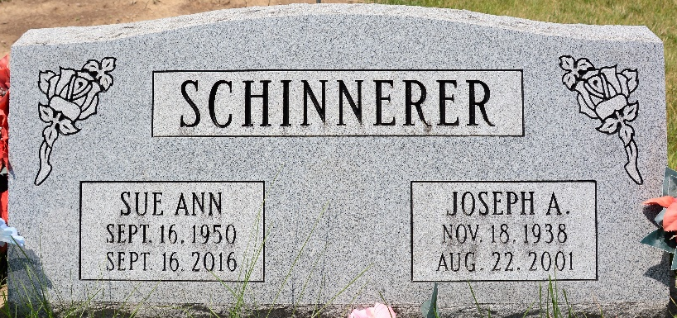
Photo by Deb Curry

Joseph A. Schinnerer, 62, of Decatur, a native of Willshire, Ohio, died Wednesday, Aug. 22, 2001, at Woodcrest of Decatur. He was retired in 2000 from Fleming Excavating and had worked for Prestress Services and Central Soya.
He had been ministered to by Hoagland Antioch Lutheran Church.
Surviving is his wife, Sue; sons Ronald of Boise, Idaho, and Roger of Decatur; a stepson, Anthony James of Decatur; brothers H. George of Willshire, Ohio, Lester of Decatur and Kenny of Daleville; sisters Marlene Beard of Albany and Judy Fraley of Jay, Fla.; and four grandchildren.
Services are 1:30 p.m. Sunday at Zwick & Jahn Funeral Home, Decatur, with calling from 11:30 a.m. until services and also from 2 to 6 p.m. Saturday. Burial will be at Decatur Cemetery.
Memorials are to the Family Hospice of Northeast Indiana.

Zwick & Jahn Funeral Home, Adams County, Indiana
August 23, 2001

**
Indiana, U.S., Death Certificates, 1899-2017
Name Joseph Arthur Schinnerer
Gender Male
Race White
Age 62
Marital Status Married
Birth Date 18 Nov 1938
Birth Place Wilshire Ohio
Death Date 22 Aug 2001
Death Place Decatur, Adams, Indiana, USA
Death Registration Date 2001
Father Arthur Schinnerer
Mother Helen Spring
Spouse Sue A
Informant Sue A. Schinnerer; wife; Decatur, Indiana
Burial: August 26, 2001; Decatur Cemetery; Decatur, Indiana

