Sue Ann (Bales) Schinnerer-Grandlinard
September 16, 1950 – September 16, 2016

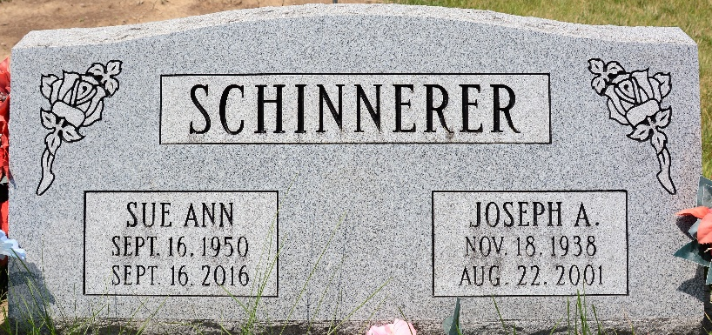
Photo by Deb Curry

Sue Ann Grandlinard, 66 years old of Decatur, Indiana, passed away on Friday, September 16, 2016 at Lutheran Hospital in Fort Wayne. She was born on Saturday, September 16, 1950 in Bluffton, Indiana the daughter of the late Charles William Bales and the late Dixie E. (Betz) Merriman. She married Joseph Schinnerer on February 18, 1984 and he preceded her in death on August 22, 2001.
Sue was a homemaker. She was a member of the F.O.E. #2653 of Decatur and a former member of the Moose Lodge in Bluffton. Surviving are her son, Tony (Dallas) James of Decatur; three grand-sons, Austin James, McKenzie James, & Trenten Schinnerer; step-son, Roger Schinnerer of Decatur; step-son, Ron Schinnerer of Boise, ID; five surrogate grandchildren, Alexander & Odilon Olvera and Soyla, Alma, & Gonzalo Garcia; brother, Jerry (Vicki) Bales of Rome City, IN; brother, James (Leon Barnwell) Bales of Butler, IN; sister, Abby Rose of Kendallville, IN; sister, Rayna (Jim) Herron of Kendallville, IN; brother, Randall Robinson of Kendallville, IN; sister, Tamara (Terry) Boothby of Decatur, IN; sister, Donna Niblick of Kendallville, IN; step-sister, Mary Ann (Ray) Bruns of New Palestine, IN; and her nephews & caregivers, Branden (Jeremy) Harrison Beeman of Decatur, IN.
Preceding Sue in death were two brothers, Arthur Harrison and Kevin Bales and a sister, Kimberly Bales.
Funeral services will be held at 10:30 a.m. Wednesday, September 21, 2016 in the Zwick & Jahn Funeral Home. Interment will follow in the Decatur Cemetery.

Zwick & Jahn Funeral Home, Adams County, Indiana
September 16, 1950 – September 16, 2016

**
Indiana, U.S., Marriage Certificates, 1960-2012

Name Sue A Schinnerer
[Sue A Bales]
Gender Female
Age 53
Birth Date abt 1951
Birth Place Indiana
Marriage Date 7 Aug 2004
Marriage Place Decatur, Adams, Indiana, USA
Marriage Registration Date 2004
Reference Number 1 Bx1451
Reference Number 2 Tr8651
Father William Bales
Mother Dixie I Bales
Spouse Kevin D Grandlinard
Box Number NA
Volume Number 45-48
Certificate Number 022108

