Kathleen Sue Schindler
June 25, 1955 – January 11, 2010

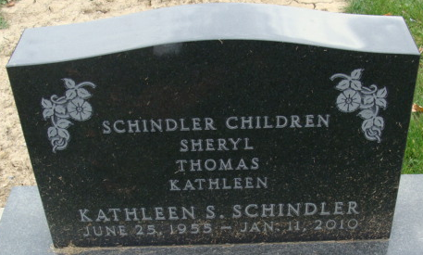
Photo by Alicia Kneuss

Kathleen Sue Schindler, 54, of Ellenton, Florida, passed away at 6:35 p.m. Monday, January 11, 2010 in the Manatee Memorial Hospital located in Bradenton, Florida following a brief illness.
Kathleen was born on June 25, 1955 in Decatur, Indiana the daughter of the late Eugene Schindler and Mary (Beer) Schindler-Snyder, who survives. Kathleen was a former member of the Decatur Church of Christ. Kathleen retired from General Electric in Fort Wayne, Indiana after 32 years of service.
Surviving are her Mother & Step-father, Mary Schindler-Snyder & Bill Snyder of Decatur, IN; brother, Tom (Deb) Schindler of Decatur, IN; sister, Sherry (Steve) Haggerty of Rocky Mount, NC; niece, Jill (William) Sanders of Pink Hill, NC; niece, Megan Haggerty of Bailey, NC; niece, Emily (Dwane) Richardson of Rocky Mount, NC; niece, Elizabeth Haggerty of Rocky Mount, NC; niece, Julia Schindler of Decatur, IN; nephew, Aaron (Jessica) Haggerty of Wilson, NC; nephew, Jaime Schindler of Fishers, IN; nephew, Bryan Schindler of Decatur, IN. Kathleen was preceded in death by one nephew, Andrew Haggerty.
A Memorial Service will be held at 3:00 p.m. Saturday, January 23, 2010 in the Zwick and Jahn Funeral Home, Decatur, Indiana. Friends and family will be received from 1:00 -3:00 p.m. Saturday, January 23, 2010 in the Zwick and Jahn Funeral Home, Decatur, IN.
Preferred memorials are to the American Lung Association.

Zwick & Jahn Funeral Home, Adams County, Indiana
January 12, 2010

