Joseph Edmund Schindler
October 11, 1932 – March 26, 1999

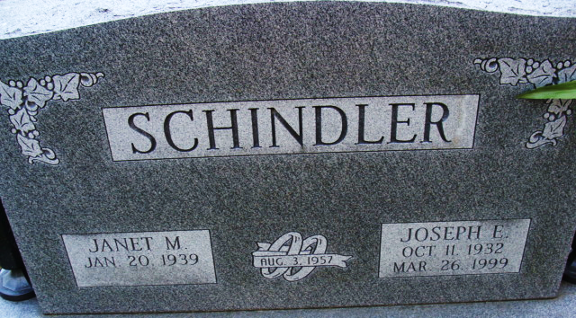
Photo by Alicia Kneuss

Joseph E. Schindler, 66, of Decatur, a Korean War Air Force veteran, died Friday, March 26, 1999, at Lutheran Hospital. The Bryant native was a self-employed painter and drywaller. Most recently, he was an employee at Bandido's Inc. in maintenance.
Surviving are his wife, Janet W.; sons Joseph J. and John J., both of Decatur, and Steven J. of Effingham, Ill.; daughters Suzanne Bloemker of Noblesville and Juli Sordelet of Churubusco; a brother, James A. of Fort Wayne; sisters Marjorie Justin of Fishers, Estella Ransom and Frances Schindler, both of Fort Wayne; and three grandchildren. He was preceded in death by his brothers, Eugene "Chico" and Louis, and sisters Ruth Schindler and Marianne Stewart.
Services are 11 a.m. Monday at Zwick & Jahn Funeral Home, Decatur, with calling from noon to 4 and 5 to 8 p.m. Sunday. Burial will be in Decatur Cemetery.
Memorials are to the donor's choice.

News-Sentinel, Allen County, Indiana
Saturday, March 27, 1999

