Janet M. (Grandstaff) Schindler
January 20, 1939 – January 19, 2022

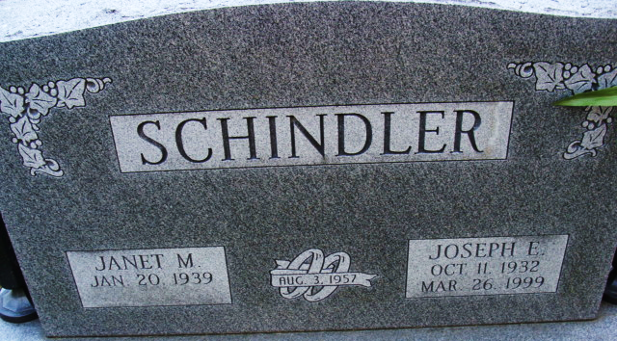
Photo by Alicia Kneuss

Janet M. Schindler, 82, of Decatur, passed away on Wednesday, January 19, 2022, at her residence. She was born in Decatur, Indiana, on January 20, 1939, the daughter of the late Gerald J. and Phyllis C. (Kosht) Grandstaff. On August 3, 1957, she married Joseph E. Schindler, he preceded her in death on March 26, 1999.
She attended and graduated from Monmouth School and attended First United Methodist Church. After graduation, she was employed at Lincoln Life, Jimmies Pizza in Portland, Nowaks Hallmark and Curves.
Janet was also a homemaker, most importantly, enjoyed raising her family. She liked to write poetry and stories, paint, do crafts, listen to music and loved history. Janet also enjoyed spending time outside in nature and traveling.
She is survived by her two sons, Steven J. Schindler of Wesley Chapel, FL and John J. Schindler of Decatur, IN; two daughters, Suzanne (Wes) Bloemker of Naples, FL and Juli (Timothy) Sordelet of Columbia City, IN; grandchildren, Bradley (Angelina) Sordelet, Dana (Cody) Warner, Caroline Bloemker; great grandchildren, Jakob Jones and Wyatt Sordelet.
Janet was preceded in death by a son, Joey J. Schindler (in 2019); a brother, Jerry Grandstaff; two sisters, Donna Fuelling and Audrey Shaw.
A Graveside Service will be held in Decatur Cemetery, at a later date.

Haggard & Sefton Funeral Home, Adams County, Indiana
January 20, 2022

