Madaline (Martin) Schilling
October 16, 1909 – September 5, 1949

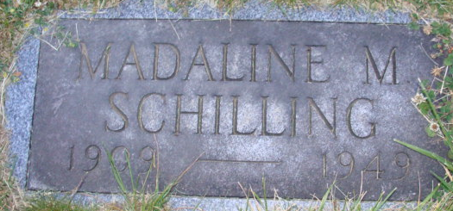
Photos by Alicia Kneuss

Funeral services for Mrs. Madaline Schilling, 39, of Wren, who died at the home of her father-in-law, Louis Schilling, east of Decatur, after a years' illness, will be conducted Friday at 1:30 p.m. at the Louis Schilling residence and at 2 p.m. at Pleasant View Baptist Church, Rev. C. B. Turner to officiate. Burial will be in Decatur Cemetery.
She is survived by her husband, A. L. Schilling; a daughter, Carolyn Sue, and a half-brother, Zephere Marion.
Friends may call at the Louis Schilling residence after 7:30 p.m. today.

Unknown source

**
Death • Ohio Deaths, 1908-1953

Name Madaline Schilling
Sex Female
Age 39
Birth Date 16 Oct 1909
Birthplace Fulton, Indiana
Race White
Previously Married N
Father's Name George Martin
Father's Sex Male
Mother Unknown
Event Type Death
Event Date 05 Sep 1949
Death Place Harrison Township, Van Wert County, Ohio
Informant: Arden Schilling
Burial: September 9, 1949; Decatur Cemetery; Decatur, Indiana
Source Details Certificate

