Philip L. Schieferstein
January 8, 1872 – January 16, 1959

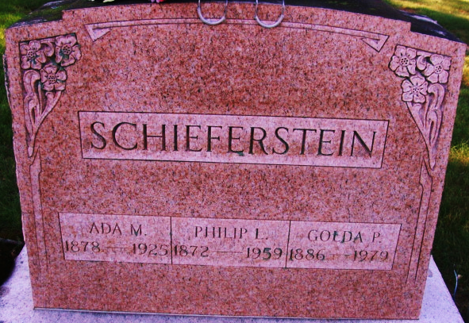
Photos by Alicia Kneuss

Philip L. Schieferstein
in the Indiana, U.S., Death Certificates, 1899-2017
Name Philip L. Schieferstein
Gender Male
Race White
Age 87
Marital Status Married
Birth Date 9 Jan 1872
Birth Place Indiana
Death Date 16 Jan 1959
Death Place Decatur, Adams, Indiana, USA
Death Registration Date 1959
Father George Schieferstein
Mother Elizabeth
Informant: Mrs. Goldie Schieferstein; wife; Decatur, Indiana
Burial: January 19, 1959; Decatur Cemetery; Decatur, Indiana
**
Phil L. Schieferstein is one of the prominent residents of Root Township and has spent nearly all the years of his active manhood in cultivating one of the admirably situated and fine farms of that vicinity.
He and his family are well known in Adams and Allen counties. Mr. Schieferstein was born in Marion Township of Allen County, January 9, 1872. He is a son of George and Elizabeth (Brown) Schieferstein, old time residents of Allen County. George Schieferstein came to the United States from Prussia, Germany, in 1850. He was a single man then, had given service for three years in the German army, and came to this country in company with the Brown family, whose daughter he afterward married.
His first home in Indiana was a small log cabin about five miles from Fort Wayne on the Peter Smith farm. He lived there about two years, and his principal occupation was cutting cord wood at 20 cents a cord. He was poor but industrious, a man of strict probity, got along well with his neighbors, and in the course of time his labors began to show fruit. In 1861 he bought a farm of his own, consisting of eighty acres, and from that time forward his prosperity has been on the increase. The land which he bought was acquired by Government title and was in an absolutely primitive condition. He cleared away a few acres and built the humble home in which his son Phil and six other children were born. Four of the family are still living: Harry, Fred, Phil and George. The daughter Christina died several years ago.
George Schieferstein in 1881 bought fifty-five acres in Root Township of Adams County, and this is the land now occupied by Henry Schieferstein. Phil Schieferstein grew up at the old home in Allen County, acquired a common school education, and by experience and observation has perfected himself as a practical and progressive farmer. His home is in Root Township, a short distance from the old Village of Monmouth and about three miles north of Decatur.
Phil Schieferstein married Miss Ada May Lewton, daughter of L. W. and Mary Lewton, of Monmouth, Root Township. To their marriage were born three children, Thurman D., Marlow F. and Elizabeth Hattie. These children have all had the advantages of the local district and high schools. Mrs. Schieferstein has brothers and sisters named C. D., Amos, Edgar, Effie M. and Daisy. Effie married L. W. Frank and Daisy married Vesta Brokaw.
Mr. Schieferstein bought two other farms in Root Township, the McConnell and Bottenberg farms, comprising altogether 117 acres. The family are members of the Lutheran Church.

Standard History of Adams and Wells Counties, Indiana, Vol. II, John W. Tyndall & Orlo Ervin Lesh; Chicago: Lewis Publishing Co, 1918

