Marlow F. Schieferstein
April 8, 1905 – November 11, 1971

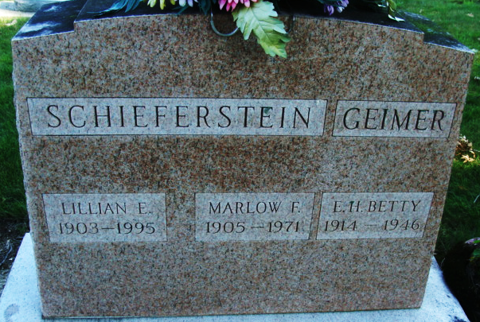
Photo of Alicia Kneuss

Marlow Schieferstein dies; veteran Schafer Co. employee
Marlow F. Schieferstein, 66, of Decatur Route 3, an employee of the Schafer Co. for nearly 20 years, was dead on arrival at 7:20 p.m. Thursday at the Adams County Memorial Hospital.
Mr. Schieferstein was enroute home, northbound on the Monmouth Road, when he was apparently stricken and his vehicle left the road, striking a guy wire. Exact cause of death has not been determined.
He was born in Decatur April 8, 1905, a son of Philip and Ada Lewton-Schieferstein, and was married to Lillian Greiner Oct. 9, 1928. He had been an employee of the Schafer Co. since May 31, 1952, and was supervisor of the cutting room.
Mr. Schieferstein was a member of the Zion Lutheran Church and the Loyal Order of Moose, of which he was a past governor.
Surviving in addition to his wife are a son, Norman P. Schieferstein of Decatur; two daughters, Mrs. Raymond (Bonnie) Lehman of New Haven, and Mrs. Kathy Miller of Decatur; his stepmother, Mrs. Golda Schieferstein of Bluffton; a brother, Thurman D. Schieferstein of Decatur Route 3; and nine grandchildren. One sister is deceased.
Funeral services will be conducted at 2 p.m. Sunday at the Winteregg-Linn Funeral Home, with Rev. Paul Ludwig officiating. Burial will be in the Decatur Cemetery. Friends may call at the funeral home after 7 p.m. today until time of the services. The Moose Lodge will hold memorial services at 7:30 p.m. Saturday.
Preferred memorials are to the Cancer Society.
Decatur Daily Democrat; Adams County, Indiana
Friday, November 12, 1971

**
Schieferstein Death is Traffic Fatality
The death of Marlow F. Schieferstein, 66, veteran employee of the Schafer Co. in this city, has been ruled due to injuries suffered in a one vehicle accident Thursday evening. Mr. Schieferstein was pronounced dead on arrival at the Adams County Memorial Hospital at 7:20 p.m. Thursday.
Coroner Richard Linn, after further examination of the body late Friday, ruled death caused by a badly ruptured liver, apparently suffered in the accident. Only other apparent injury was a slight forehead laceration.
The Schiefersten death was the 11th traffic fatality of the year in Adams County, 10 occurring in the county, one in the city Decatur.
According to the investigation by the coroner, the Adams County Sheriff's Department and the Decatur Police Department, Schieferstein's pickup truck, in which he was enroute home, left the highway on the curve known as Millers Bend, on the Monmouth Road north of the city about 7 p.m.
The truck struck a guy wire cable on a telephone pole, causing the truck to flip over Schieferstein's fatal injury was apparently caused when he was jammed into the steering column of the truck. The accident victim had undergone surgery for removal of a lung several months ago.
Funeral services will be held at 2 p.m. Sunday at the Winteregg-Linn Funeral Home, with Rev. Paul Ludwig officiating. Burial will be in the Decatur Cemetery. Friends may call at the funeral home until time of the services. Moose Lodge memorial services will be held at 7:30 p.m. today.
Preferred memorials are to the Cancer Society.
Decatur Daily Democrat; Adams County, Indiana
Saturday, November 13, 1971

