John H. Schieferstein
April 19, 1911 – July 18, 1992

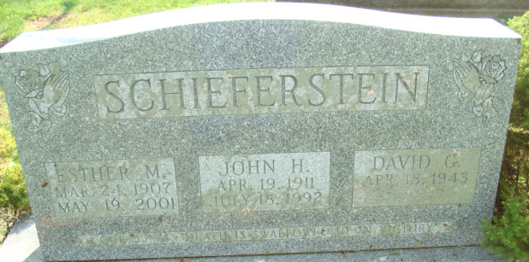
Photo by Alicia Kneuss

John H Schieferstein
in the Indiana, U.S., Death Certificates, 1899-2017
Name John H Schieferstein
Gender Male
Race White
Age 81
Marital Status Married
Birth Date 19 Apr 1911
Birth Place Monmouth, Indiana
Death Date 18 Jul 1992
Death Place Decatur, Adams, Indiana, USA
Death Registration Date 1992
Father George Schieferstein
Mother Dora Grandstaff
Spouse Esther M Debolt
Informant: Esther Schieferstein; wife; Decatur, Indiana
Burial: July 21, 1992; Decatur Cemetery; Decatur, Indiana

