Golda P. (Breiner) Schieferstein
May 2, 1886 – March 7, 1979

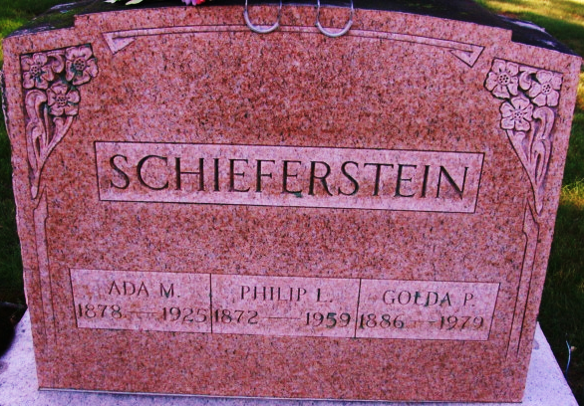
Photo by Alicia Kneuss

Golda Schieferstein
in the Indiana, Death Certificates, 1899-2011
Name: Golda Schieferstein
[Golda Breiner]
Gender: Female
Race: White
Age: 92
Marital status: Widowed
Birth Date: 2 May 1886
Birth Place: Indiana
Death Date: 7 Mar 1979
Death Place: Bluffton, Wells, Indiana, USA
Father: William Breiner
Mother: Mary Hower
Informant: Mrs. Rachel White; Bluffton, Ind.
Burial: March 10, 1979; Decatur Cem., Decatur, Ind.

