George Schieferstein
May 4, 1878 – August 29, 1959

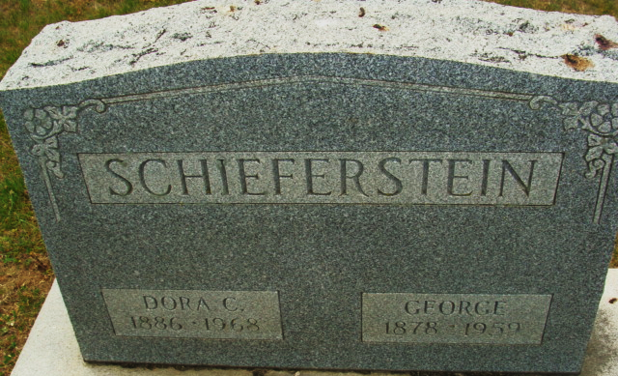
Photo by Alicia Kneuss

George Schieferstein
in the Indiana, U.S., Death Certificates, 1899-2017
Name George Schieferstein
Gender Male
Race White
Age 81
Marital Status Married
Birth Date 4 May 1878
Birth Place Indiana
Death Date 29 Aug 1959
Death Place Decatur, Adams, Indiana, USA
Death Registration Date 1959
Father George Schieferstein
Mother Elizabeth Braun
Informant: Mrs. George Schieferstein; wife; Monmouth, Indiana
Burial: September 1, 1959; Decatur Cemetery; Decatur, Indiana
**
Will of George Schieferstein

Name in Record Reason for Being in Record Date of Record
George Schieferstein Of Adams County; makes his last will & testament Nov. 3, 1958
Dora C. Schieferstein Wife; inherits entire estate
John H. Schieferstein Son; to inherit entire estate if Dora Schieferstein is deceased
Esther Schieferstein Wife of John H. Schieferstein
Dora C. Schieferstein Wife; appointed executrix of will of George Schieferstein
Anna J. Nesswald Of Adams County; witnessed George Schieferstein making his will
Severin H. Schurger Of Adams County; witnessed George Schieferstein making his will
George Schieferstein Died Aug. 29, 1959
Severin H. Schurger Oath of death Sept. 2, 1959
Richard D. Lewton Clerk
Severin H. Schurger Subscribing witness; oath of validity of will Sept. 2, 1959
Richard D. Lewton Clerk

