Esther M. (DeBolt) Schieferstein
March 24, 1907 – May 19, 2001

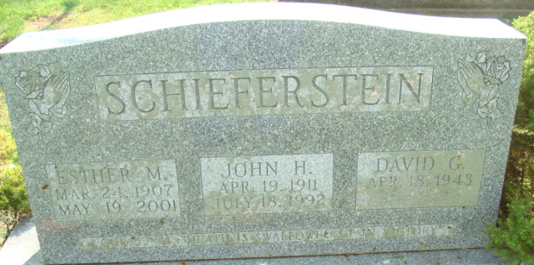
Photo by Alicia Kneuss

Esther M Schieferstein
in the Indiana, U.S., Death Certificates, 1899-2017
Name Esther M Schieferstein
[Esther M Debolt]
Gender Female
Race White
Age 94
Marital Status Widowed
Birth Date 24 Mar 1907
Birth Place Adams County Indiana
Death Date 19 May 2001
Death Place Decatur, Adams, Indiana, USA
Death Registration Date 2001
Father John H Debolt
Mother Amelia W Deinerj
Informant: Mrs. Nola Rains; daughter; Decatur, Indiana
Burial: May 22, 2001; Decatur Cemetery; Decatur, Indiana

