Dora C. (Grandstaff) Schieferstein
August 23, 1886 – August 21, 1968

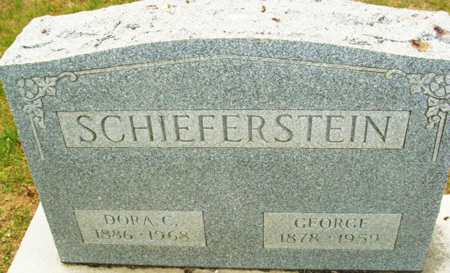
Photo by Alicia Kneuss

Dora C Schieferstein
in the Indiana, U.S., Death Certificates, 1899-2017
Name Dora C Schieferstein
Gender Female
Race White
Age 81 years
Marital Status Widowed
Birth Date nothing stated
Birth Place Indiana
Death Date 21 Aug 1968
Death Place Decatur, Adams, Indiana, USA
Death Registration Date 1968
Father Lemuel Grandstaff
Mother Alice Katherine Dutcher
Informant: John H. Schieferstein; son; Decatur, Indiana
Burial: August 23, 1968; Decatur Cemetery; Decatur, Indiana

**
Indiana, U.S., Marriages, 1810-2001
Name Dora Grandstaff
Gender Female
Race White
Age 20
Event Type Marriage Registration (Marriage)
Birth Date 23 Aug 1886
Birth Place Root Twp, Adams, Indiana
Marriage Date 8 May 1907
Marriage Place Indiana, United States
Residence Place Root Twp, Adams, Indiana
Father Lemuel Grandstaff
Mother Catharine Dutcher
Spouse George Schieferstein
Page 158
FHL Film Number 002321466

