David G. Schieferstein
April 18, 1943 – July 16, 2017

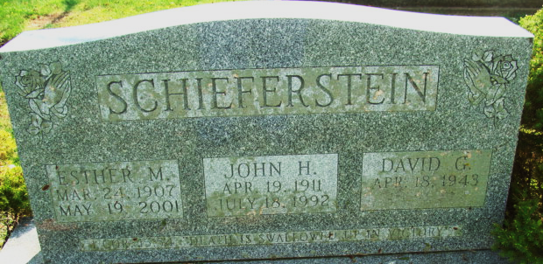
Photo by Alicia Kneuss

David G. Schieferstein was born on Sunday, April 18, 1943 in Decatur, the son of the late John H. Schieferstein and the late Esther M. (DeBolt) Schieferstein.
David served his country in the United States Army National Guard. He was a member of Antioch Lutheran Church in Hoagland. David was employed at Monroe Automatic Sprinklers for 24 years, retiring on June 19, 1989.
Surviving is his sister, Nola C. (Rodney) Rains of Decatur, IN; niece, Esther (Ryan) Pope of Decatur, IN; nephew, John Rains of Decatur, IN.
Funeral services will be held at 10:00 a.m. Friday, July 21, 2017 in the Zwick & Jahn Funeral Home, Decatur with Pastor David Taylor officiating. Interment will follow in the Decatur Cemetery. Friends will be received from 4-8 p.m., Thursday, July 20 in the Zwick & Jahn Funeral Home, Decatur.
Preferred memorials are to Antioch Lutheran Church; PAWS of Adams County Indiana, Building Fund; and One Spirit Indian Reservation.

Zwick & Jahn Funeral Home, Adams County, Indiana
July 16, 2017

