Ada M. (Lewton) Schieferstein
June 15, 1878 – October 30, 1925

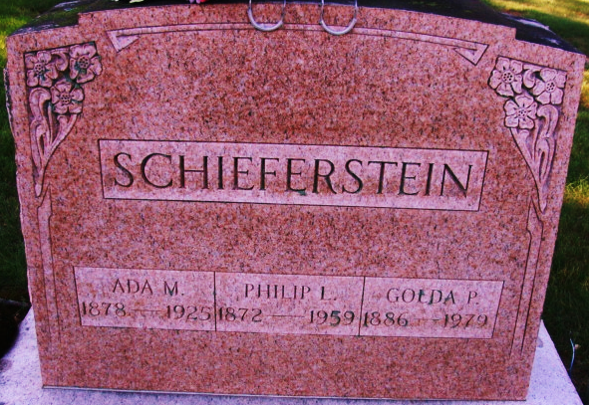
Photos by Alicia Kneuss

Ada Lewton Schefers
in the Indiana, U.S., Death Certificates, 1899-2017
Name Ada Lewton Scheferstine
[Ada Lewton Jeroten]
Gender Female
Race White
Age 47
Marital Status Married
Birth Date 15 Jun 1878
Birth Place Root Adams Co, Indiana
Death Date 30 Oct 1925
Death Place Decatur, Adams, Indiana, USA
Death Registration Date 1925
Father: Lewis Lewton
Mother: Mary Robison
Spouse: Philip Scheferstine
Informant: Philip Schieferstine; Decatur, Indiana
Burial: November 2, 1925; Decatur, Indiana

